Extra Measures in Rachmaninoff’s G-Minor Prelude, Op. 23, no. 5.

Word count: 3423 words (not counting the bibliography)

The title of this article alludes to Andrew Imbrie’s 1973 article “’Extra’ measures and metrical ambiguity in Beethoven.” Imbrie’s point is that, in movement 1 of the Fifth Symphony, after many regular four-bar hypermeasures, Beethoven adds an extra bar towards the end of the development, so that the performer and the listener need to switch to a new hypermetrical pattern—from even-strong to odd-strong (terms by David Temperley 2008, meaning a shift from strong even-numbered measures to strong odd-numbered ones;). Beethoven’s notated measures remain the same throughout, but the perceived hypermetric accent shifts.
The situation in Rachmaninoff’s G-Minor Prelude (1901, published in 1904) is different: here, the notated measure changes from 4/4 to 2/4, twice in the course of the piece; see mm. 9 and 16 in Example 1. The purpose of this paper is to show that, like the tip of an iceberg, this seemingly innocuous change of time signature is connected to a set of interrelated phrase-rhythmic and formal processes, invisible at first sight. The extra beat, which produces the 2/4 measures, reveals a lot about the piece: how the perceived (versus notated) measure changes as the form unfolds; how phrase-structural asymmetry engenders multiple ways to hear metrical shifts; and how these shifts relate to formal functionality and formal becoming in Janet Schmalfeldt’s sense. More specifically, I offer one possible reading of the opening section (four-square phrases framed by non-thematic material) and what happens with it in the recapitulation, which simultaneously resolves metrical ambiguities posed earlier and creates new ambiguities of formal function. I also suggest a possible re-notation of bar lines as an alternative reading of the metrical irregularity. The terminology I use in form analysis is William Caplin’s (1998 and 2013).
My more general objective is to reinforce the urge of several theorists of meter (among them Lerdahl and Jackendoff, whose metrical preference rules are aimed at musical signals as opposed to notation; and William Rothstein, especially 1995 and 2008) to think beyond ostensible bar lines, and not take them at face value as simple and indisputable facts. An attempt to find the origin of a metrical anomaly may lead to a deeper understanding of the piece’s internal workings. A secondary objective is to explore how Rachmaninoff creatively transforms formal structures (such as the period and the ternary form) which originate in late 18th-century practice, and which he had internalized during his studies (1888–92) at the Moscow Conservatory. This task is inspired by the recent efforts of Formenlehre theorists (especially Julian Horton, 2015, and Steven Vande Moortele, 2013) to explore questions of applicability of Classical formal taxonomies to post-Classical music.
First, a brief overview of the prelude’s form is in order. (I will return to the large-scale form at the end of this article.) Example 2 shows a ternary form or ABA’, where the large-scale A section is itself a small ternary with a truncated recapitulation. Henceforth, I will refer to the different levels of form as A and B at the large scale, and “a” and “b” at the small scale.
The two anomalous 2/4 measures are confined to the “a” section, on which I will now focus. As a first step, let’s disentangle the length of the perceived measure. The very fact that a 2/4 bar occurs in the midst of a 4/4 piece suggests that the half-note might be the dominant metrical unit in the A and A’ sections, which therefore could be notated in 2/4 throughout. This hearing is confirmed in the notated mm. 3–4 (debatably the fragmentation area of a sentence), where the repeated rhythmic motive sixteenth–sixteenth–dotted-quarter takes exactly one half-note. In other words, the real measure equals two notated measures (R = ½ N), to use Caplin’s terms (2013, 63–64). This suggests the eighteenth-century notion of compound measure (see Floyd Grave 1985), where the notated measure represents two perceived measures. While I do not insist that the R = ½ N is the “right” way hear it, I do encourage the reader to focus on the half-note as a basic metrical beat, no matter how many bar lines one wishes to have. Lerdahl and Jackendoff’s concept of the tactus, perhaps, best describes the idea.
With the basic half-note beat in mind, I now turn to questions of phrase structure and form. The two anomalous 2/4 measures signify an uneven number of half-note beats. In its turn, this can signify two things: either some the phrases are inherently asymmetrical, or symmetrical phrases have been shifted with respect to an underlying regularity. The former option is not uncommon in Rachmaninoff. Some examples of his most asymmetrical phrases and unpredictably changing meter signature come in pieces that stylistically reference Russian folk or church music. But the G-minor prelude’s march topic (see the alla marcia marking), as well as its rhythmically repetitive character, suggest the second possibility—that the piece might have an underlying symmetrical structure. The next few paragraphs will prove that this is a fruitful idea. But first we need to ask this: what is the phrase in the opening sixteen measures? Their overall form is periodic, where the antecedent takes up mm. 1–9 (HC in G minor) and the consequent mm. 10–16 (PAC), although the antecedent’s cadence is somewhat compromised with respect to classical/ early-Romantic norms. But how are the antecedent and the consequent organized internally?
The question yields no automatic answer, and the reason lies in the curious lack of melodic material per se. This becomes clear if one attempts to sing the beginning: it is not easy to understand which melodic idea defines the prelude, although it is very clear which textural and rhythmic patterns define it: the low arpeggiated bass segment and the mid-register chords with two sixteenths and an eighth. And yet, to analyze form, one needs to decide on the local form-functional beginning—that is, the basic idea (and this is as much an analytical as it is a performance decision). There are two options: the basic idea enters either in m. 1 (melodic line in the lowest register) or in the middle of m. 3 (melodic line D-F-G in the middle register). I choose the latter option, thus rendering the preceding music a local introduction (Caplin’s “thematic introduction, or Rothstein’s “prefix”).
Since my overall argument depends on the form of this section, the relative advantages of the two readings deserve closer attention. The advantages of the b.i. in m. 3 include phrase-rhythmic symmetry and form-functional efficiency of section “a” (to be shown soon), the line’s relative “singability,” the register, and the presence of an actual harmonic progression, I–“III_{6/4}”–iv₆–V with striking outer-voice counterpoint (marked in Example 3). The alternative reading—basic idea in m. 1—suggests a local sentence: basic idea in m. 1, its repetition in m. 2, and fragmentation in the following measures. This sentential reading supports the R = ½ N idea, since the succession of “real” half-note measures is 2+2+1+1+1+1. The disadvantage is primarily form-functional: while the sentence works internally, the following music is harder to explain, especially mm. 5–9.
The choice to hear the basic idea in m. 3 allows for a distinction between two types of material—melodic, which begins with the D-F-G line, and accompanimental, which may be called framing material, to adapt Caplin’s term “framing function.” One might also think of them as thematic and non-thematic material, or essential and non-essential (an 18th-century distinction recently revived in Poundie Burstein’s, 2024, work on Graun and Koch). The thematic material forms four symmetrical phrases (marked in Example 1), whose structure is 4+4+4+4 half-notes. To use Rothstein’s term (1989, 65), this is the basic length of the “a” section, the length to which the music can be reasonably reduced and still sound coherent. It is also the form-functional body of section “a,” a compound period I will henceforth call the “structural period,” where each large phrase is a hybrid. The internal structure of each hybrid is a c.b.i. (compound basic idea) plus continuation. (One might argue for an additional HC in m. 5; but its cadential status is undermined by the consequent, where the corresponding point, m. 14, is decidedly non-cadential).
The symmetry of these four phrases allows one to explain the anomalous 2/4 measures in terms of shifts with respect to the structural period’s underlying regularity. (It is this four-square construction (relevant especially in light of the march topic) that ultimately makes the alternative reading—the sentence starting in m. 1—less convincing.) Example 3 (a and b) focuses on the interaction of the structural period and the framing material. The half-note is notated as the real measure here, so the time signature is 2/4. The insertions of framing material are asymmetrical, and they also constitute a significant departure from Classical forms: five half-note beats in the thematic introduction (whose formal placement is conventional), another four beats interpolated between the two halves of the antecedent (a form-functional surprise!), and another five in an introduction to the consequent (an uncommon placement). That makes for 14 half-notes outside of the structural period, but they are unevenly distributed. It is this uneven distribution of framing material that necessitates the anomalous measures in two separate places. It is not difficult to see which beat is “extra”: the one that creates five-beat units, the fifth half-note in both thematic introductions. One could logically take out these two beats and have a more regular, 4-beat introduction without any harmonic discontinuity. So, if the half-note is the real measure, then there are, after all, extra measures in this piece!
But, while phrase structure determines which half-note is “extra,” only metrical analysis can determine which 4/4 measure is “too short”—in other words, at which specific point the metrical disturbance takes place. So far, I have considered the music in terms of half-note beats. But what about the 4/4 time signature—the composer’s notational choice, and a two-bar hypermetrical unit for those who prefer to hear the 2/4 bar as the real measure?
There are two answers depending on how one hears the structural period—as beginning-accented or as end-accented. Both Example 3 (2/4 time signature) and Example 4 (4/4 time signature), suggest a beginning-accented pattern, at the level of four half-notes. Example 4 rearranges the bar lines to emphasize beginning-accent within the structural period. In this reading, in each phrase of four half-notes, the first half-note is strong and is notated as a downbeat. This might sound logical to many, and the energetic opening of the antecedent supports this reading. The tonic chord at the first beat of the antecedent and the consequent suggest a beginning-accent too (Lerdahl and Jackendoff’s metrical preference rule 9, or Rothstein’s “stability rule”). Since the introduction is clearly beginning-accented (the first and third half-notes are strong thanks to the low bass notes), the extra beat just before the antecedent results in two consecutive strong beats at the junction of the introduction and the antecedent, producing a metrical reinterpretation, or deletion (term from Lerdahl and Jackendoff 1983, 70). This is why the renotated version in Example 4 transfers the anomalous 2/4 measure to the point immediately prior to the antecedent and the consequent.
But this, of course, is not how Rachmaninoff chooses to notate it. Instead, he implies an end-accented pattern, notating the time-signature change in mm. 9 and 16, and placing the second and fourth half-notes in the structural period on downbeats. This forces a metrical reinterpretation of the beat directly following the two cadences. The visual markedness of the cadences as the anomalous 2/4 measures perhaps suggests and they are the strongest, the hypermetrical accent at the 4-half-note level and maybe even the 8-half-note level. (A later recomposition of this material, however, undermines this impression; see analysis of the recapitulation, below.)
Whichever metrical reading one prefers, however, the phrase-rhythmic irregularities—including the five-beat introduction and the unexpected interpolation—create an impression of reluctance, a metaphorical “trial and error” or “stop-and-go.” This observation supplies a transition to the last part of my analysis—the large-scale form (revisit Example 2).
The “reluctant” character of the “a” section is entirely gone in the rest of the piece, and the anomalous 2/4 measure also never comes back. This happens for a different reason in each formal area. First, the local “b” section (not shown) is phrase-rhythmically regular; its medial character is primarily in the sequential progression (chord roots Eb–Bb–D; F–C–Eb). The local a’ section is truncated and preserves only the first out of four phrases of the original compound period. There is still framing material, but it works differently this time. This section is twenty half-notes long, arranged as 5+4+11 (the last eleven are post-cadential, a local standing-on-the-dominant after a HC). It is once again asymmetrical, but it happens to have an even number of beats, and no extra half-note is needed. The large-scale B section is mostly metrically regular. It brings new thematic material, lyrical and—unlike the melodically fragmentary A section—with a real melody. The slower melodic development, as well as the broader sweeps of the accompaniment, suggest a change to an alla breve measure (a whole-note long, rather than a de facto 2/4, which returns in the A’ section). The B theme consists of two sentence-like phrases, both of which begin and end on the dominant harmony, D. There is a single hypermetrical shift (reinterpretation) at m. 42, right after the first sentence has been compressed by a measure.
Finally, the prelude’s large-scale recapitulation deserves more attention. What we might initially expect is a return of the opening small ternary. Instead, the composer presents us with remnants of this opening theme. Its “a” section is replaced with a new passage that uses the framing material, 14 notated measures long (equals 28 half-notes, so it does not require a change of time signature). The symmetrical contrasting middle (b) remains the same as before. Finally, the small-scale recapitulation (a’) is entirely gone, replaced with a lengthy post-cadential passage prolonging the G-minor tonic. This falling-apart of the former ternary theme suggests Schmalfeldt’s idea of becoming (known graphically as the double arrow =>): retransition=>a; b is still b; and a’=>post-cadential. This is the kind of recapitulatory recomposition that Ellen Bakulina (2020, 72) terms a dissolving recapitulation (most typical for Rachmaninoff’s solo songs). The becoming, or transformation of formal function, is perhaps the most Romantic formal feature in this work.
The retransition=>a requires some comment, as it also helps understand why the anomalous 2/4 measures disappear. The reason is the near-absence of thematic material in the recapitulation. At the prelude’s beginning, each extra half-note occurs at the form-functional junction of framing and thematic material. In the recapitulation, however, the identity of these two types of material collapses. When the opening arpeggiated motive comes back after the middle section, one expects that this material is still introductory with respect to the structural period. At the same time this passage is retransitional, since it begins on the B section’s last harmony (V) and sequentially proceeds towards the tonic. But neither the antecedent nor consequent of the initial period ever comes back, and we reinterpret (hence the becoming sign) the arpeggiated framing material as essential to the recapitulation. Russian theorist Valentina Kholopova (1979) calls such situations thematized texture (tematezirovannaya faktura), a textural pattern made prominent enough to sound thematic. The extra beat no longer occurs because its original form-functional context—the collision of essential and non-essential material—is gone. Example 5 shows the moment where the “framing material” continues past its original length, and the listener gradually realizes that the former antecedent is not coming back. This is a formal surprise, but it removes all the phrase-rhythmic surprises. The recapitulation is completely regular up to the level of four half-notes, an inexorable, rhythmically undisturbed drive towards the final cadence at m. 72.
And here is a final point about the recapitulation that ties into the metrical questions of the beginning: the cadence of the retransition=>a section, PAC in m. 63. Its location in the recapitulation corresponds to the PAC in m. 16 in the A section, the focus of the phrase-rhythmic mysteries discussed earlier. Example 6 places the two cadences side by side for comparison. In m. 16, the half-note unit that contains the V–I cadential progression is notated as a strong beat, suggesting an end-accented vision of the periodic phrases. In the recapitulatory m. 63, the corresponding unit falls on the weak part of the 4/4 measure, thus suggesting a beginning-accented version. True, the recapitulation contains enough changes to possibly hear these two “a” sections as largely unrelated. And yet, the two PACs in 16 and 63 are correlated based on their analogous formal placement and their rhythmic and harmonic similarity. This suggests that, after all, Rachmaninoff might have meant both these cadential segments as metrically weak, and their corresponding phrase beginnings as strong, in spite of his bar-line placement in the opening section. This, in its turn, supports my idea (Example 4) that the “real” anomalous 2/4 measure should occur at the end of the brief thematic introduction, around the notated measures 3 and 12, and not where the composer notates them! One might perhaps see m. 63 as the answer to the questions posed by the initial section: how the accents are arranged within the structural period, and how they interact with the extra beat, the resulting metrical reinterpretations, and the anomalous 2/4 measure.
In summary, I have argued that the opening section of the prelude contains a somewhat hidden symmetrical period; that the extra half-note occurs in the two local introductions within this period; that the comparison of sections A and A’ suggest a change of time signature in mm. 3 and 11 (as opposed to 9 and 16); and that the disappearance of this metrical disturbance in the recapitulation is due to the dissolution of the initial structural period. In conclusion, I wish to emphasize that one could not fully understand the interconnection of all these issues without considering meter and form together.

Works Cited

Bakulina, Ellen. 2020. "The Loosening of Closure: a Form-Functional Study of Sergei
Rachmaninoff’s Solo Songs." Theory and Practice 45: 51–92.
Burstein, L. Poundie. 2024. “The Best Laid Plans . . . and Others: An 18th-Century Compositional
Outline.” SMT-V 10:1 (January 2024).
Caplin, William E. 1998. Classical From: A Theory of Formal Function for the Instrumental Music of Haydn, Mozart, and Beethoven. Oxford University Press.
_______. 2013. Analyzing Classical Form: An Approach for the Classroom. Oxford University
Press.
Grave, Floyd. 1985. “Metrical Displacement and the Compound Measure in Eighteenth- Century Theory and Practice.” Theoria 1: 25–60.
Horton, Julian. 2015. “Formal Type and Formal Function in the Post-Classical Piano Concerto.” In
Formal Functions in Perspective: Essays on Music Form from Haydn to Adorno, ed.
Steven Vande Moortele, Julie Pedneault-Deslauriers, and Nathan John Martin: 77–122.
Imbrie, Andrew. 1973. “’Extra’ Measures and Metrical Ambiguity in Beethoven.” In Beethoven Studies, ed. Alan Tyson: 45–66. Norton.
Kholopova, Valentina. 1979. Faktura. [Texture.] Moscow: Sovetskiy Kompozitor.
Lerdahl, Fred, and Ray Jackendoff. 1983. A Generative Theory of Tonal Music. MIT Press.
Moortele, Steven Vande. 2013. "In Search of Romantic Form." Music Analysis 32/3: 404–31.
Rachmaninoff, Sergei. 1948 [1904]. 24 prelyudii dlya fortepiano. Edited by Pavel Lamm. Moscow: Muzgiz.
Rothstein, William. 1995. “Beethoven with and without Kunstgepräng’: Metrical Ambiguity
Reconsidered.” In Beethoven Forum 4, ed. Lewis Lockwood and James Webster.
_______. 2007 [1989]. Phrase Rhythm in Tonal Music. Ann Arbor: Musicalia Press.
_______. 2008. “National Metrical Types in Music of the Eighteenth and Early Nineteenth
Centuries.” In Communication in Eighteenth-Century Music, ed. Danuta Mirka and Kofi
Agawu, 112–59. Cambridge University Press.
Schmalfeldt, Janet. 2011. In the Process of Becoming. Oxford University Press.
Temperley, David. 2008. "Hypermetrical transitions." Music Theory Spectrum 30/2: 305–25.

Example 1. Sergei Rachmaninoff. Prelude in G Minor, op, 23, no. 5. Mm. 1–16. Rectangles show the two anomalous measures of 2/4. Brackets show thematic material.

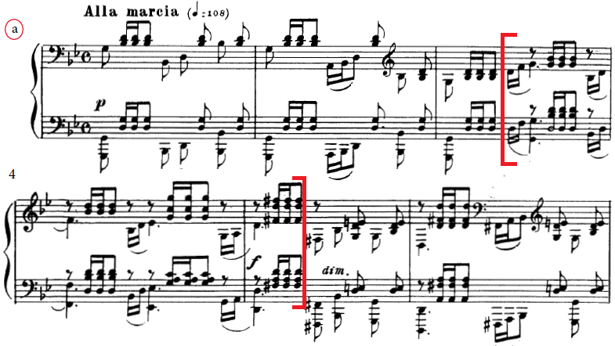
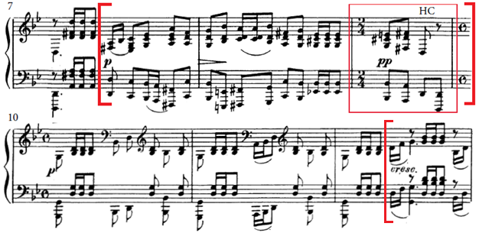
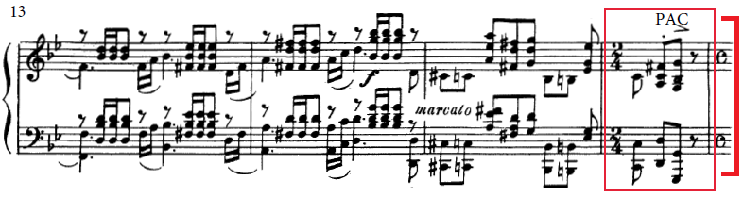

Example 2. Prelude in G Minor, formal diagram.

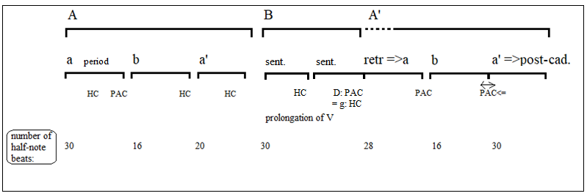
Example 3a. Section “a,” renotated in 2/4. Formal and metrical analysis. Circled numbers refer to half-note beats (1 = strong). 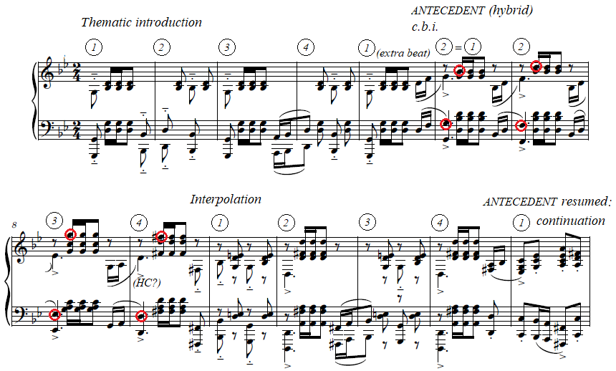
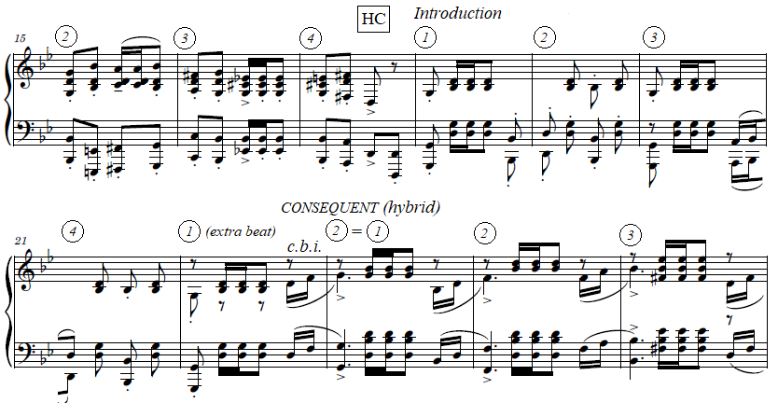

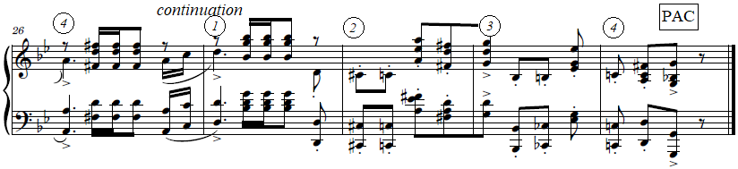

Example 3b. Section “a,” formal diagram.

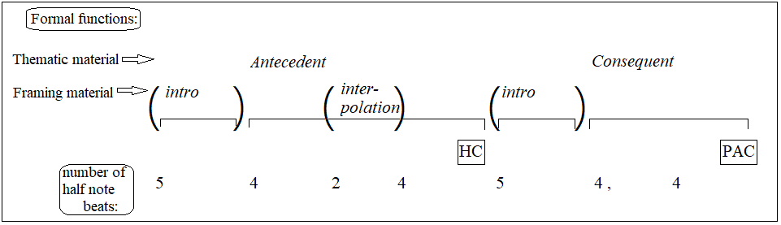

Example 4. Mm. 1–4 re-barred to place the anomalous 2/4 measure as m. 3. Circled numbers refer to the half-note beats (1 = strong).

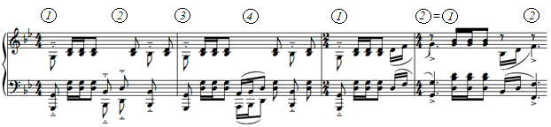

Example 5. Retransition=>a, mm. 50–56.
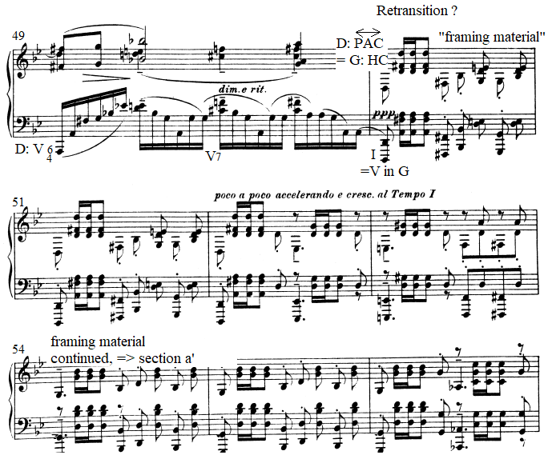

Example 6. Comparison of the two PACs: m. 16 and m. 63.
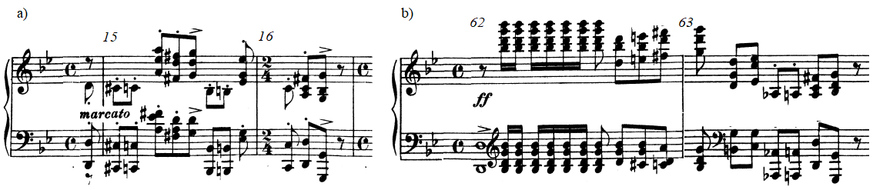

Lerdahl and Jackendoff’s (1983, 21) concept of tactus refers to the level of meter most prominent for perception.
The song “Uzh ty niva moya” op. 4 no. 5, the E-minor prelude from op. 32, and much of the 1915 All-Night Vigil illustrate this affinity.
Another piece of Rachmaninoff’s that plays with an 18th-century topic, in this case the minuet, is the D-Minor prelude, op. 23 no. 3.
Strictly speaking, m. 9 does not qualify as a HC in Caplin’s taxonomy, since he requires the cadential dominant to enter in root-position form, whereas this V first occurs in a 6/4 position. One solution to this problem is to consider the V6/4 on the second eighth-note of m. 9 as an anticipation of the “real” V on the second quarter note. Alternatively, one might call m. 9 a “dominant arrival” (Caplin 2013, 224) instead of a true cadence. (Of course, this problem is in place no matter how one reads the form of the antecedent.) What matters here is, not so much the cadential status of m. 9, but the regular phrase structure of the thematic material and its broadly periodic shape. I will continue to refer to m. 9 as a HC, with the understanding that a HC may be a looser concept in early 20th-century music compared to music around 1800.
A third option would be a hypermetrical transition (concept from Temperley 2008) between the odd-strong beginning and the even-strong ending of the antecedent. The consequent would then do the opposite: transition from even-strong to odd-strong hypermeter.
I will show below that the large-scale recapitulation indirectly supports the beginning-accented reading.
In the alternative, sentential reading of mm. 1–5, the extra beat would fit with a third, incomplete statement of the basic idea (the b.i. corresponding in this case to m. 1) and the beginning of the continuation (notated mm. 3–5)
The post-cadential function of the final section comes from a lengthy tonic harmony (sustained for either four or seven measures depending on individual reading), followed by repeated cadential progressions—a typical post-cadential technique (Caplin 2013, 135).
In the alternative (sentential) reading of the opening measures, the recapitulatory passage I read as retransition=>a’ would be a series of presentation-like phrases, what Rothstein (1989, 296) a stollen process.
In the A section, the corresponding cadence is shown as a HC before the tonic chord. In the recapitulation, this tonic is retrospectively reinterpreted as the final PAC as the remaining music prolongs the tonic in a post-cadential fashion.

